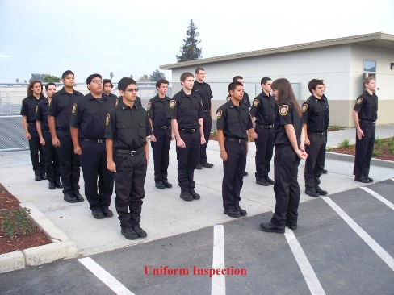Fire Technology EMR Uniform

Uniform Inspection

Students are expected to acquire a uniform:

* Black Dickies dress shirt
* Black Dickies work pants
* Black belt with a chrome buckle or a fire service type buckle
* Black work boots
* Navy blue shorts

A navy blue T-shirt and patches will be provided. The patches are to be sewn onto the dress shirt. See instructor with questions and concerns. Do not remove tags from clothing until instructors deems clothing acceptable. We have some donated items to help families that cannot afford to purchase the uniform. Tip: Nothing should stand out-students in uniform should all look similar.

|  |  |  |
| --- | --- | --- |
| Image result for black dickies pants | Image result for baggy black dickies pants |  |
| Simple Black Dress Pants | Pants-Hemmed and not baggy | No Cargo Pockets |
| Image result for black dickies Dress shirt uniform world | Image result for black work shirt | Image result for navy blue shorts russell |
| Simple Black Shirt | No pictures | Navy Blue Shorts |
|  | Product Details | Image result for dickies belt |
| Buckle should be chrome | No Fancy Buckles | No Braid |
| Image result for dickies boots | Image result for work boots black with fabric | Image result for work boots black with fabric |
| Leather work boots | No fabric, no steel toe | No Neon |